**MODES**

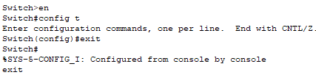

**SETTING SWITCH USERNAME AND PASSWORD**

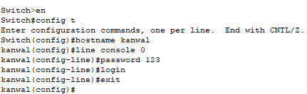

**SETTING PRIVILEGE MODE PASSWORD**

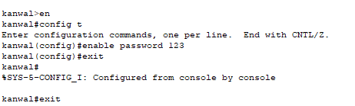

**SETTING PRIVILEGE MODE ENCRYPTED PASSWORD**

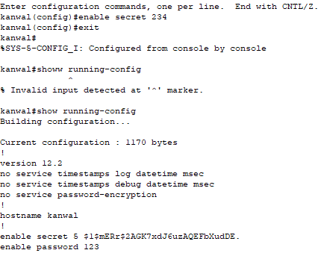

**SETTING USERNAME AND PASSWORD**

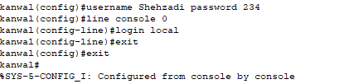

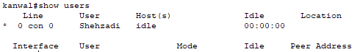

**ENCRYPT ALL PASSWORDS AT ONCE**

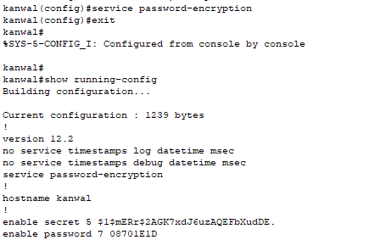

**BANNER**

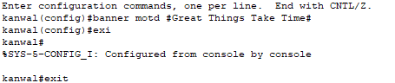



**CLOCK**





**ENCRYPTED LINE CONSOLE PASSWORD**

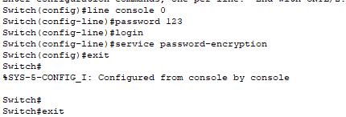

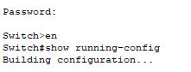



**ENABLING PRIVILEGE MODE PASSWORD**



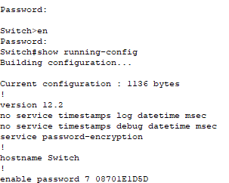



**ENABLING USERS PASSWORD**

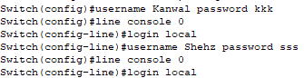

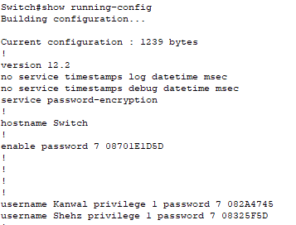

**DELETE USER**

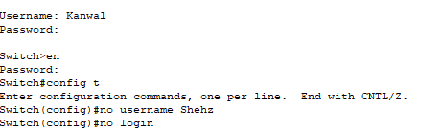

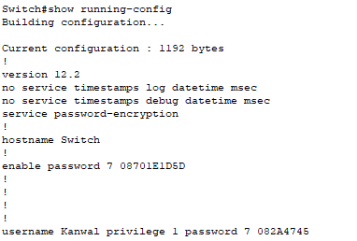

**SETTING MODES**

**FOR SERVER**

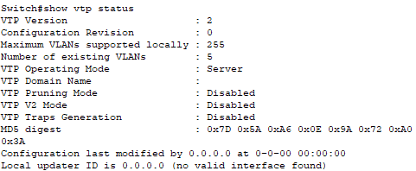

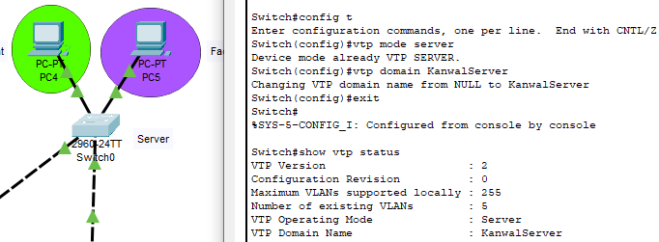

**FOR CLIENTS**

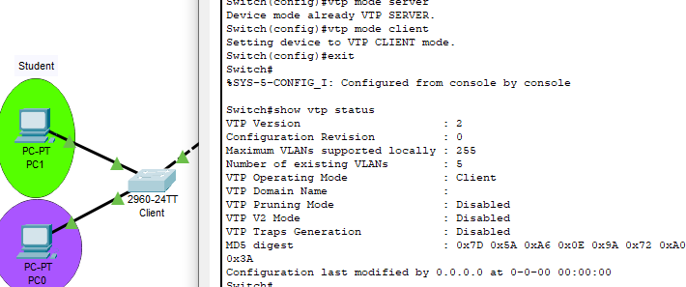

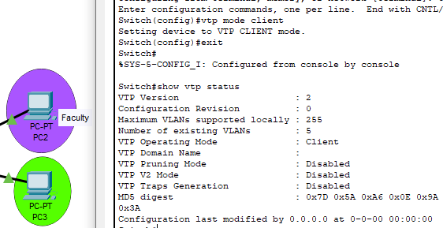

**FOR TRANSPARENT**

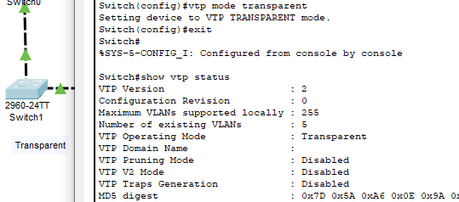

**TRUNKING FOR FIRST CLIENT**

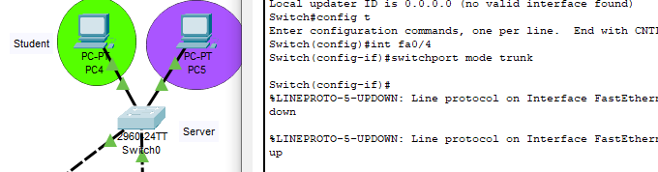

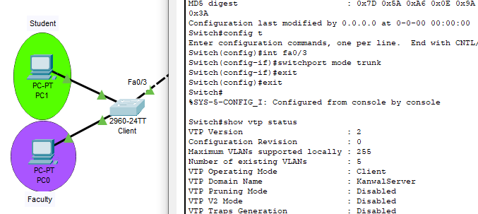

**TRUNKING FOR SECOND CLIENT**

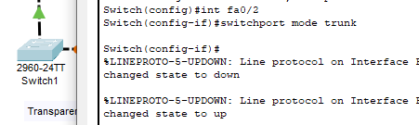

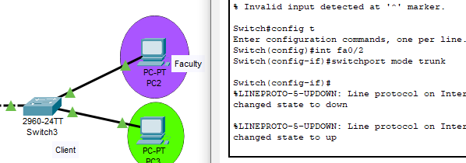

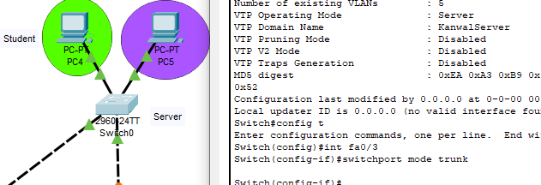

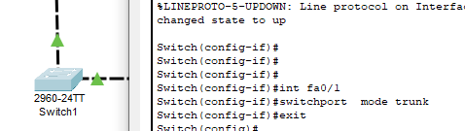 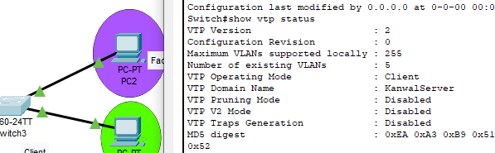

**SETTING UP VLAN IN THE SERVER**

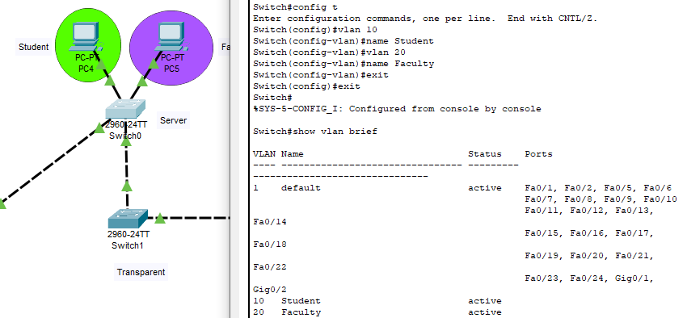

**CHECKING VLANS IN FIRST CLIENT**

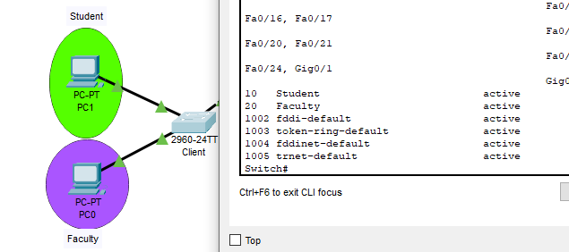

**CHECKING VLANS IN SECOND CLIENT**

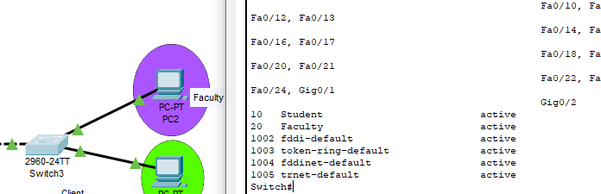

**CONFIGURING VLAN IN THE SERVER**

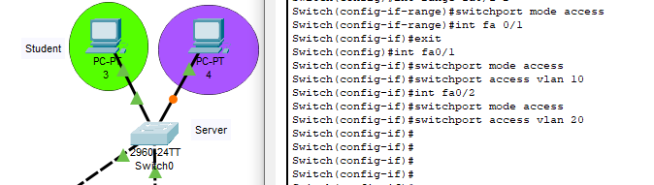

**CONFIGURING VLAN IN THE FIRST CLIENT**

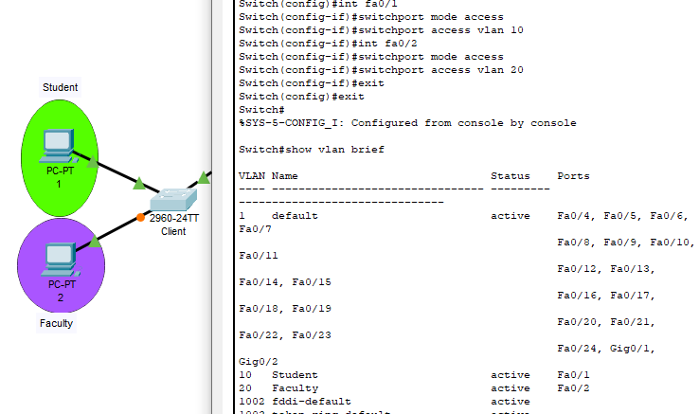

**CONFIGURING VLAN IN THE SECOND CLIENT**

